MESSIAH LUTHERAN CHURCH, ELCA
MINUTES OF THE CONGREGATIONAL COUNCIL
Tuesday, January 25, 2022
6:30 PM in person at Messiah Lutheran Church.

Present In Person: Council President Debbie Hampstead, Council Secretary Sharon Sweeney, Tom Cole, Jon Driskill, Andrew Lauber, Cristall Mount, Lori West, Michele Wilson, Andrew L, Pastor Susan Thisell.
Present Via Zoom: Mike Driskill, Rachel Rushworth-Hollander, Craig Stewart.
Absent: Becky Breeden.

- Devotions were provided by Sharon Sweeney, from Women’s Devotional Bible

- Council minutes of the December 21, 2021 meeting were included in the Council packet for review. Motion to approve by Michele Wilson, seconded by Lori West. Minutes approved.

Correspondence:

- A building use request from the Pilot Class of the Embroiderer’s Guild was included in the council packet and has already been approved as a continuing group meeting. Correspondence included a thank you from Second Harvest, a thank you from Compassion Coalition, a thank you from Care Cuts, and a thank you from Love Kitchen.

Committees:

- Finance – Balance sheet from December was approved as submitted.
It was noted that in the budget we had reduced synod giving with the understanding that we would put money back in budget as income permitted. Discussion was made about adding the synod mission support $3000 that had been removed from the budget, since we now have a surplus. If the congregation’s income requires another adjustment, the figure could be examined in a future council meeting. The balance sheet included a request for council to add the funds back into the budget.
Motion was made by Pastor Susan Thisell, second by Lori West. Motion carried.
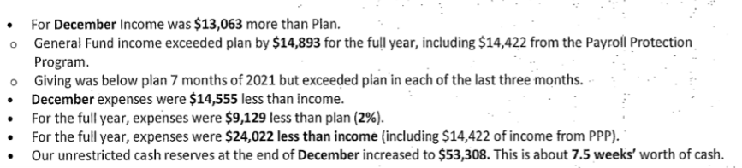
- Worship: recommend John Brock as interim choir director, pending salary agreement. Motion was made by Tom Cole, Second by Andrew Lauber.Motion carried.

- Disciple: Souper Bowl of Caring proceeds will go to Volunteer Ministry Center. Motion was made by Michele Wilson, Second by Lori West. Motion carries.

New Business:

- A discussion was made about the COVID team’s recommendation that masks be required for in person worship based on the increase of the Omicron variant. After much discussion, council decided to accept the recommendation with this wording: that out of loving respect for our neighbor we strongly urge masks. The social hour will be temporarily suspended as well. Motion by Andrew Lauber, Second by Rachel Rushworth-Hollander. Motion carried.

- Pastor’s report: Feb. 5 from 9 a.m. to 1 p.m. will be the council retreat at church. Food will be available before the meeting. The program will be about Adaptive Leadership, including planning and developing goals for the future and mapping how to get there rather than only reacting to issues. For this year’s council members, current members can receive a notebook or flash drive. Members are asked to bring flash drives back to the office to update. Documents also will be on the Cloud for reference or download, and paper updates will be offered.

- A search committee will be formed for the new music director. People interested in joining the committee: Pastor David Bradford, John Brock, Jenny Adams, Meredith Liemohn, Mary Williamson, Rick Christian, and Chris Warren. Michele Wilson made a motion to approve the committee, Lori West second. Motion carried. Erika Baldwin is a potential new member.

- Council meeting dates for the coming months will be Feb. 20, March 20, April 10, May 15, and for the summer will be Tuesday evenings. Council members will bring lunch, or we may have a soup/sandwich lunch or other easy meal.

- Ministry team liaisons will be:
Finance, Steve Hess; Worship, Lori West; Fellowship, Rachel Rushworth-Hollander; Property, Mike Driskill; Personnel, Michele Wilson; Invite, Craig Stewart; Disciple, Michele Wilson; Care, Sharon Sweeney; Stewardship, Andrew Lauber and Tom Cole, Badenhop, Becky Breeden; Diversity and Justice, Mike Driskill; Policy, Mike Driskill; Octoberfest, Craig Stewart; BAM. Jon Driskill; WELCA, Debbie Hampstead.

- Andy Waller is willing to serve on the congregational council to finish out Andrew Lauber’s term through the end of the year. Andrew will be moving to North Carolina as he attends Duke Divinity School. Motion made by Pastor Susan Thisell; Second, Michele Wilson. Motion carried.

- Congregational Meeting Part 2 will be on Sunday, Feb. 6.

- Pastor’s Housing Allowance for 2022 was presented for approval, based on an IRS requirement. Motion to approve was made by Lori West, seconded by Andrew Lauber. Motion carried.

- In the council packet is a list of leadership and committees, Each liaison needs to check who is among the members and update the list, then have it sent to Kristin and copy Debbie Hampstead. This will be our first Google Drive project as well.

- Discussion of video licensing possibility was tabled until the next meeting.

- The meeting was adjourned at 8:13 p.m. with the Lord’s Prayer.

